

Bachelor of Computer Applications (BCA) Programme

Project Report

BCA Sem VI

AY 2022-23

*Online Courses Platform*

*By*

|  |  |
| --- | --- |
| Exam No | Name of Student |
| 3237 | Vora Aryan Prafulkumar |
| 3200 | Shah Malay Ashwinkumar |
| 3160 | Parajapati Darshil Tejalkumar |

|  |  |
| --- | --- |
| Project Guide by: | |
| Prof. Jaimini Patel |  |

**Acknowledgement**

The success and final outcome of this project required a lot of guidance and assistance from many people and we are extremely fortunate to have got this all along the completion of our project work. Whatever we have done is only due to such guidance and assistance.

We would not forget to thank I/C Principal Dr. Aditi Bhatt, Head of Department Dr. Vaibhav Desai and Project guide Prof. Jaimini Patel, and all other Assistant professors of SDJ International College, who took keen interest on our project work and guided us all along, till the completion of our project work by providing all the necessary information for developing a good system.

We are extremely grateful to her for providing such a nice support and guidance though she/he had busy schedule managing the college dealings.

We are thankful and fortunate enough to get support and guidance from all Teaching staffs of Bachelor of Computer Application Department which helped us in successfully completing our project work. Also, we would like to extend our sincere regards to all the non-teaching staff of Bachelor of Computer Application Department for their timely support.

Vora Aryan Prafulkumar (3237)

Shah Malay Ashwinkumar (3200)

Prajapati Darshil Tejalkumar (3167)

*I N D E X*

|  |  |  |
| --- | --- | --- |
| **Sr No** | **Description** | **Page No.** |
| 1 | Introduction | 1 |
|  | 1.1 Project Summary | 2 |
|  | 1.2 Project Technical Profile | 3-4 |
| 2 | Scope & Planning | 5 |
|  | 2.1 Requirement Analysis | 5 |
|  | 2.2 Technology Details | 6 |
| 3 | Designing | 7 |
|  | 3.1 Data Flow Diagram | 7-12 |
|  | 3.2 Use Case Diagram | 13-14 |
|  | 3.3 ER Diagram | 15 |
|  | 3.4 Database Design | 16-18 |
|  | 3.5 User Interface | 19-45 |
| 4 | Testing | 46 |
|  | 4.1 Unit Testing | 46-47 |
|  | 4.2 Navigation Testing | 48-49 |
|  | 4.3 Functional Testing | 50 |
|  | 4.4 Environment Testing | 51 |
| 5 | Conclusion | 52 |
| 6 | Bibliography & Reference | 53 |

1. **Introduction**

An online course platform is a digital platform that provides access to educational content and courses over the internet. These platforms offer a variety of courses ranging from coding fundamentals and web development and other specialized topics.

Online course platforms provide learners with the flexibility to learn at their own pace and on their own schedule. They often use a combination of videos, interactive exercises, quizzes, and other multimedia elements to deliver their content. Many platforms also provide learners with the ability to interact with instructors and other students.

Some popular examples of online course platforms include Udemy, Coursera, and LinkedIn. These platforms typically offer both free and paid courses, with some also offering certifications or degrees upon completion of certain programs.

Learning has never been easier thanks to our Online Course Platform! All you have to do is register and you can learn from any device, wherever you are. Our education business provides you with the resources you need to get ahead and stay ahead of the game.

Take control of your education journey and evaluate yourself with our comprehensive online course platform! We offer tests that help you accurately assess your progress and learn effectively in a comfortable environment.

Our Education Online Course Platform is convenient, accessible, and full of content and features to help you reach your goals – all while letting you learn when it's most convenient for you. With our platform, you can learn at any time – anytime that works for you.

**1.1 Project Summary**

Online Course Platform is a fast and efficient way of providing and sharing knowledge with learners in different parts of the world. It is defined as the following: “Online Course Platform uses the internet or other digital content for learning and education activities, that takes full advantage of modern educational technology to provide a new mechanism for communication and learning environment rich in resources to achieve a new way of learning.”

Paper—Overview of E-Learning Platforms for Teaching and Learning

The most possible and most current distance learning is currently based on the Internet. For this, the term Online Course Platform is increasingly used to include any open and distance learning using information and communication technologies. We adopt this term as moreover in the rest of this book.

Our Online Course Platform offers you a wide range of structured curriculums to choose from. Whether you're interested in coding, design or marketing, we've got you covered! With our user-friendly interface and expert instructors, you can master new skills and advance your career in no time. Join us today and start your learning journey!

Our Online Course Platform where learning and growing becomes an effortless and pleasant experience! With our video tutorials, we provide a perfect opportunity for you to enhance your knowledge and improve your skills. You can choose from a variety of subjects and explore them at your own pace. Our platform is designed to make it easy for you to pick up new skills, balance your learning with your busy life, and achieve your goals. And, whenever you need assistance, our friendly support team is always here to help you out. So, why not begin your learning journey with us today? Let the adventure begin!

* 1. **Project Technical Profile**

|  |  |
| --- | --- |
| **Project Title** | Online Course Platform |
| **Definition** | Online Course Platform is an E- learning Platform which allows students to directly use services from a web-browser using the internet. |
| **Developed For** | SDJ International College, Vesu, Surat |
| **Project Guide(s)** | Prof. Jaimini Patel |
| **Front End** | HTML, CSS, JavaScript |
| **Scripting language** | PHP, JAVASCRIPT |
| **Back End** | MySQL, XAMPP SERVER |
| **Operating System** | Microsoft Windows 11 |
| **Designing Tools** | Bootstrap, Javascript, CSS |
| **Diagram Tools** | Draw.io, MS PAINT |

1. **Scope & Plannin****g**

**2.1 Requirement Analysis**

To develop any web application system, it is most important to identify the user requirement is in very specific manner. Also, to function properly all interfaces of proposed system with surrounding system must be identified. The correct system is that which satisfied all users requirement. Therefore, it is very important to analyze the existing system and to document the software requirement specification for proposed system which in turn provides the base for development of the proposed system.

Our project guide conducted a series of lectures to impart us the required knowledge about the system. During the lectures, we also had question and answer session at the end, which helped us to have a clear idea about the Expected system.

**2.2 Technology Detail****s**

**Hardware Requirement:**

|  |  |
| --- | --- |
| **Processor** | Intel Core i3 /AMD Ryzen 3 |
| **RAM** | 4 GB |
| **HDD** | 256 GB |
| **SSD** | 256 GB |

**Software Used for Application Implementation:**

|  |  |
| --- | --- |
| **Operating System** | Windows 10/11 |
| **Front End** | Html, CSS, JavaScript |
| **Code Behind** | PHP |
| **Back End** | MySQL |
| **Other Framework and tools** | Bootstrap, Draw.io |

1. **Designing**

**3.1 Data Flow Diagram**

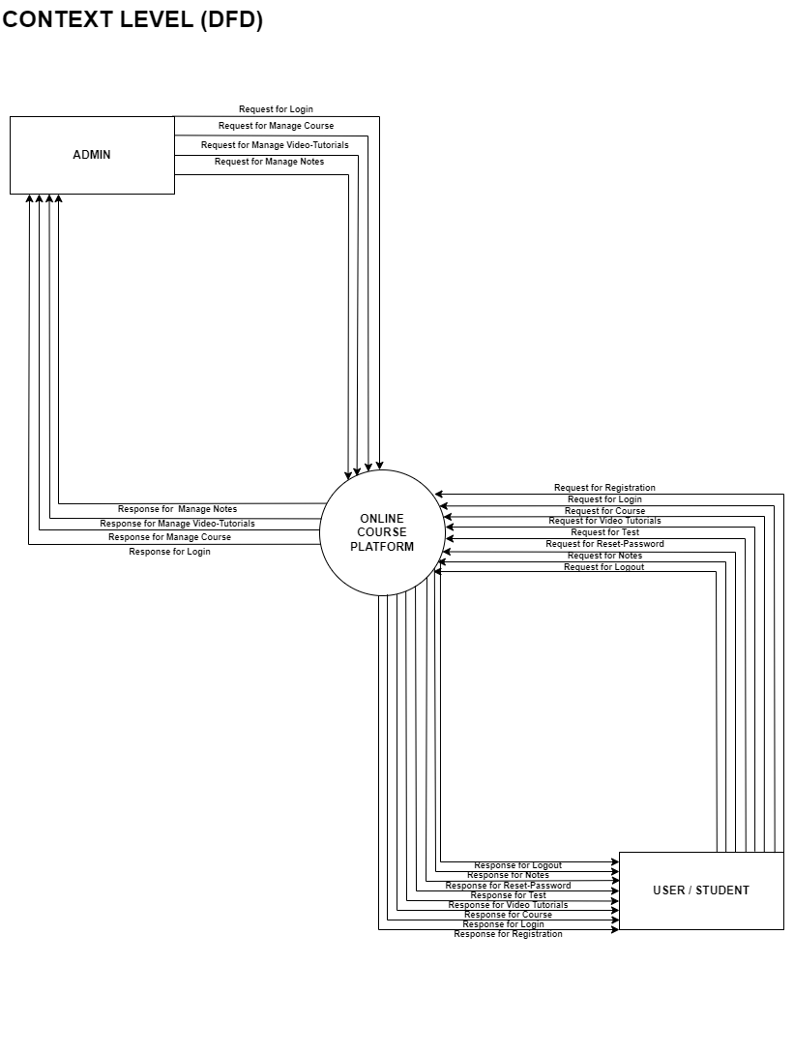

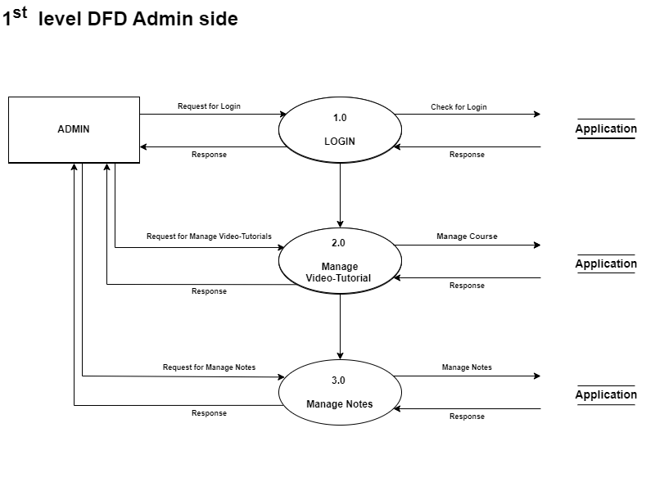

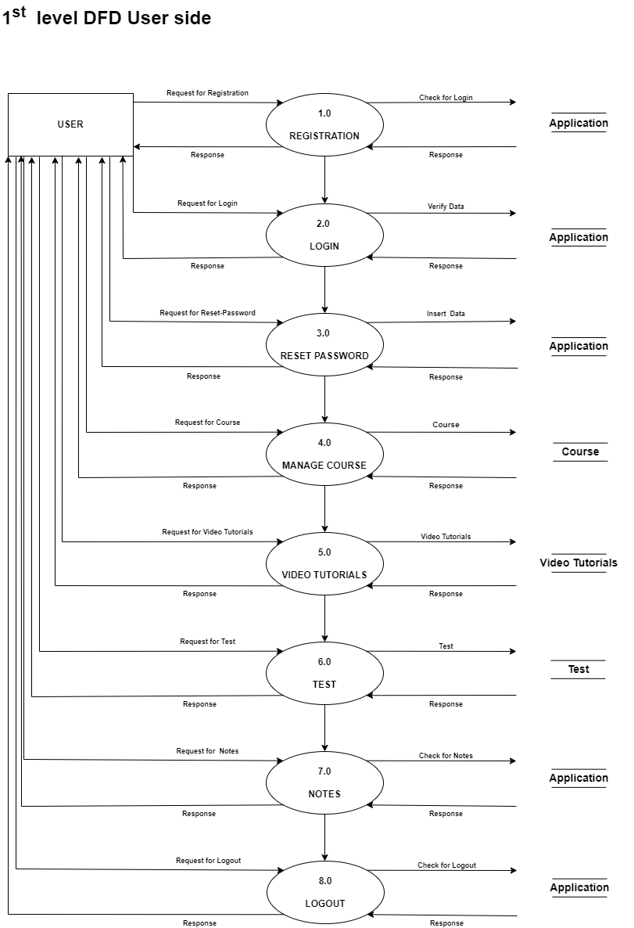

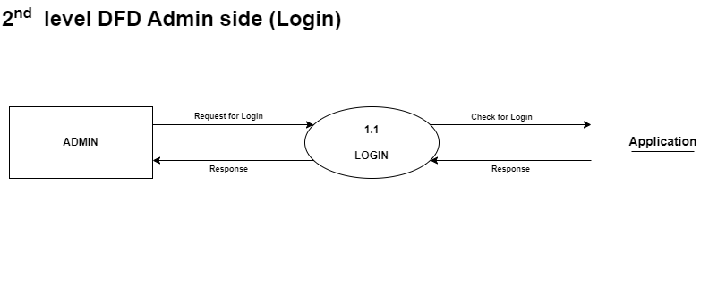

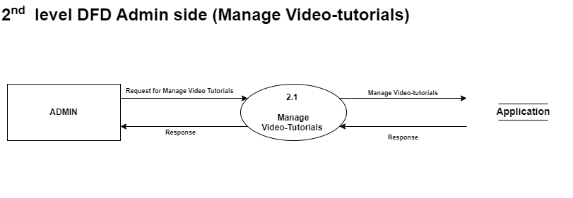

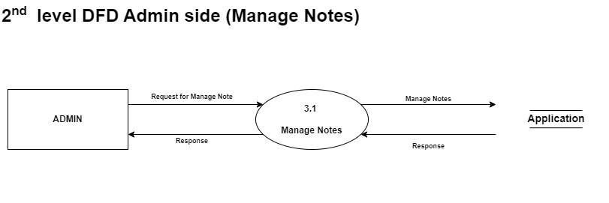

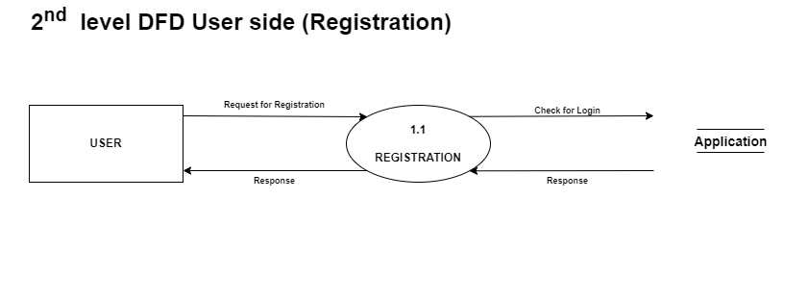

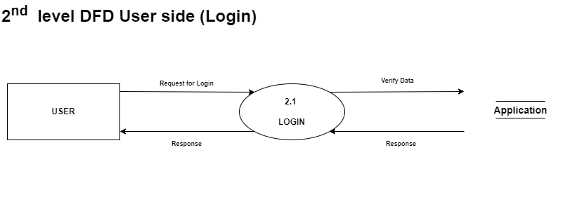

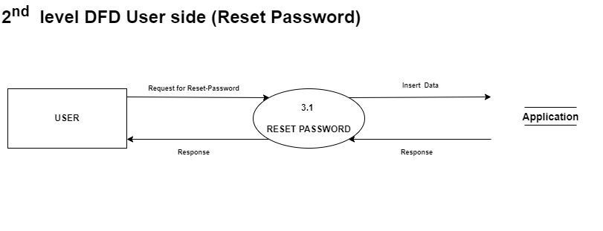

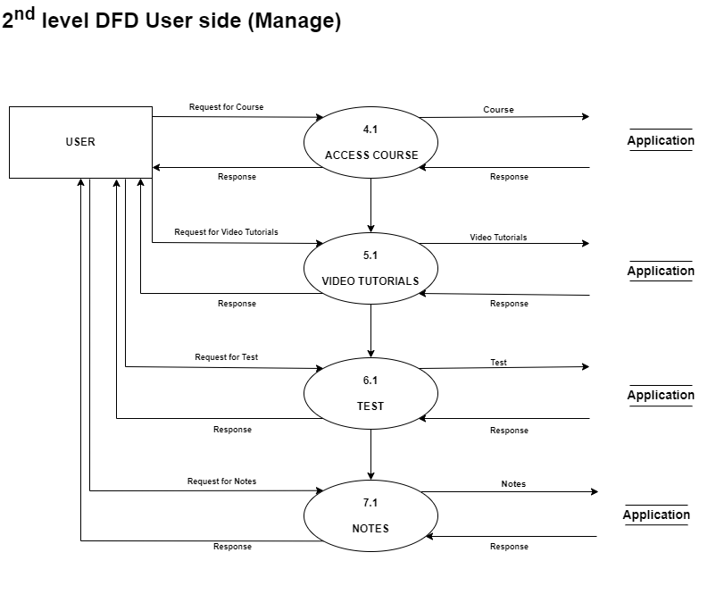

s

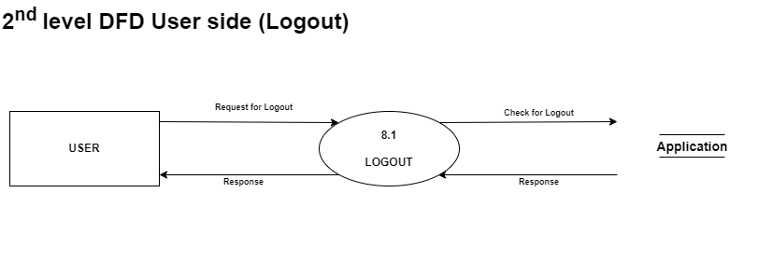

**3.2** **Use Case Diagram**

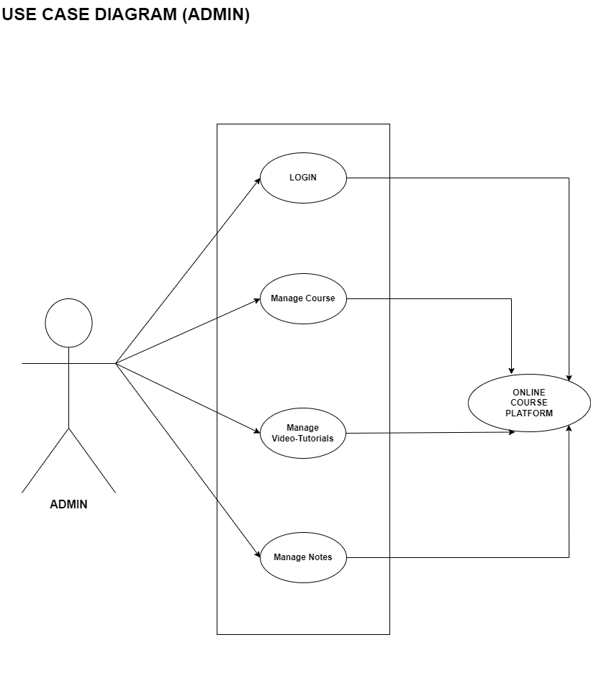

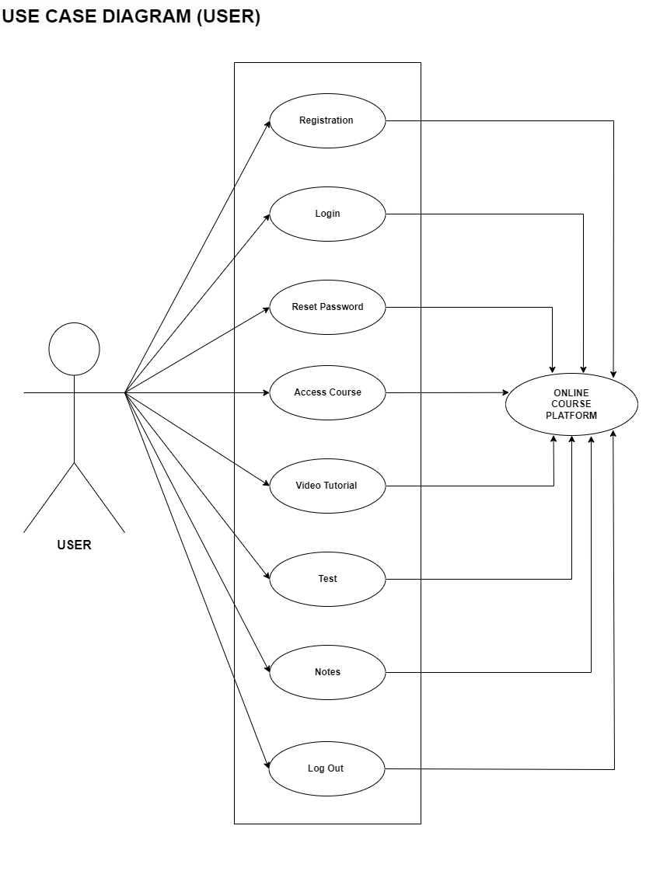

**3.3** **ER Diagram**

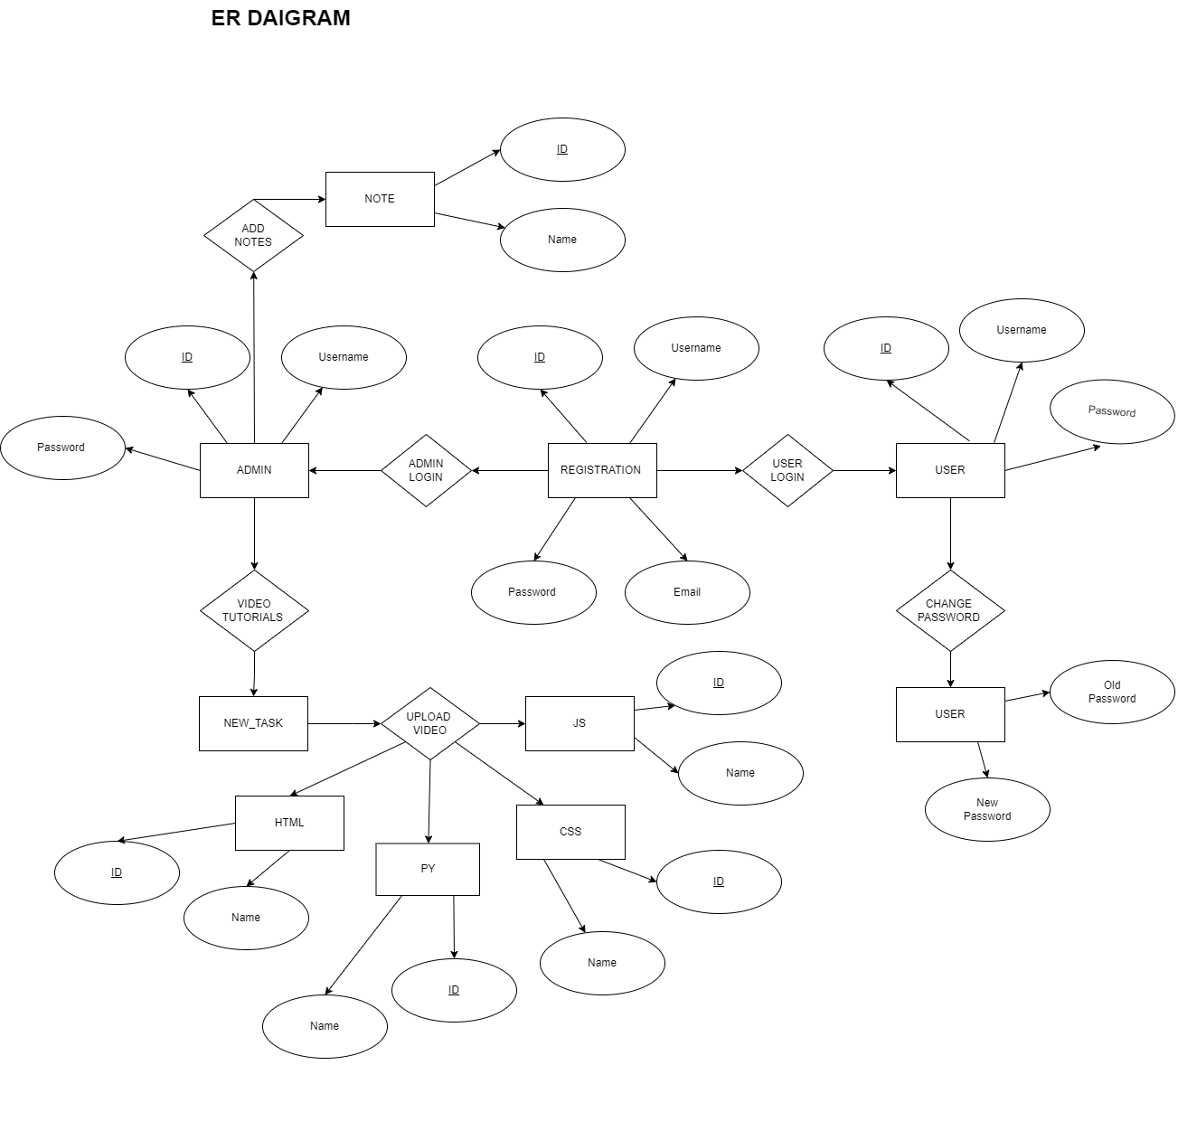

**3.4** **Database Design**

**DATABASE: loginsystem**

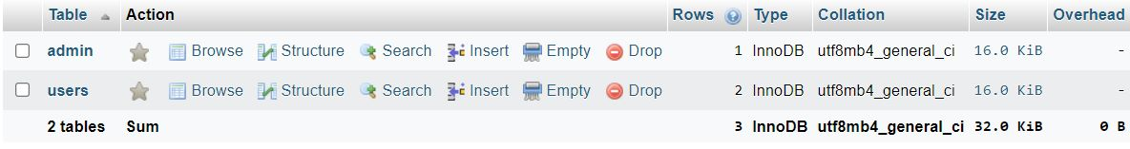

**Admin Table**

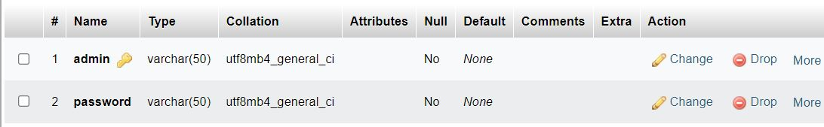

**User Table**

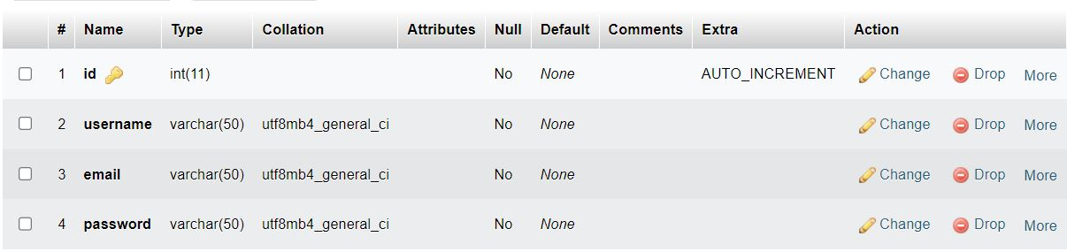

**DATABASE: new_task**

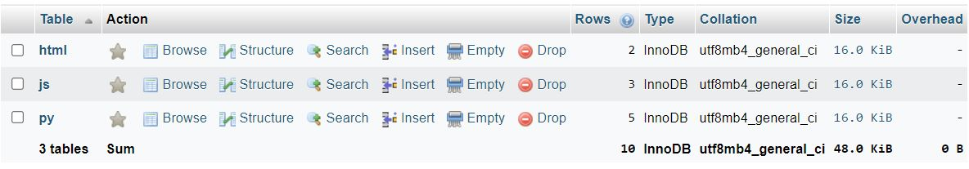

**Html Video Table**

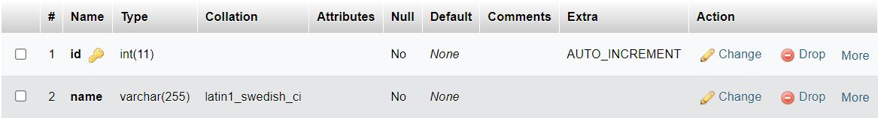

**JavaScript Table**

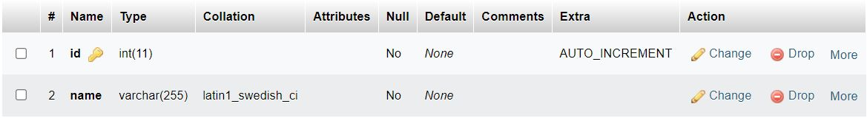

**Python Table**

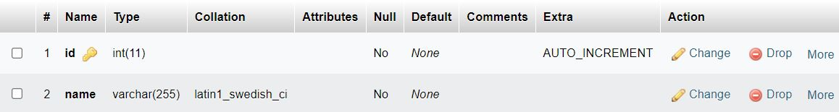

**DATABASE: notes**



**Notes Table**

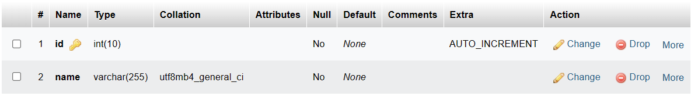

**3.5 User Interface**

**Admin**

**Admin Login**

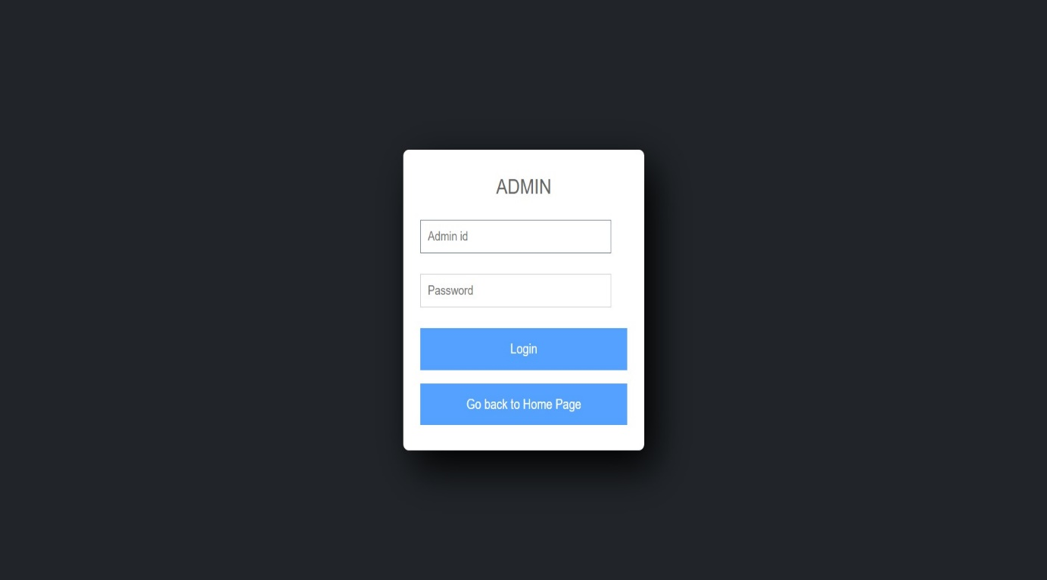

[Admin Login Page]

**Manage Page**

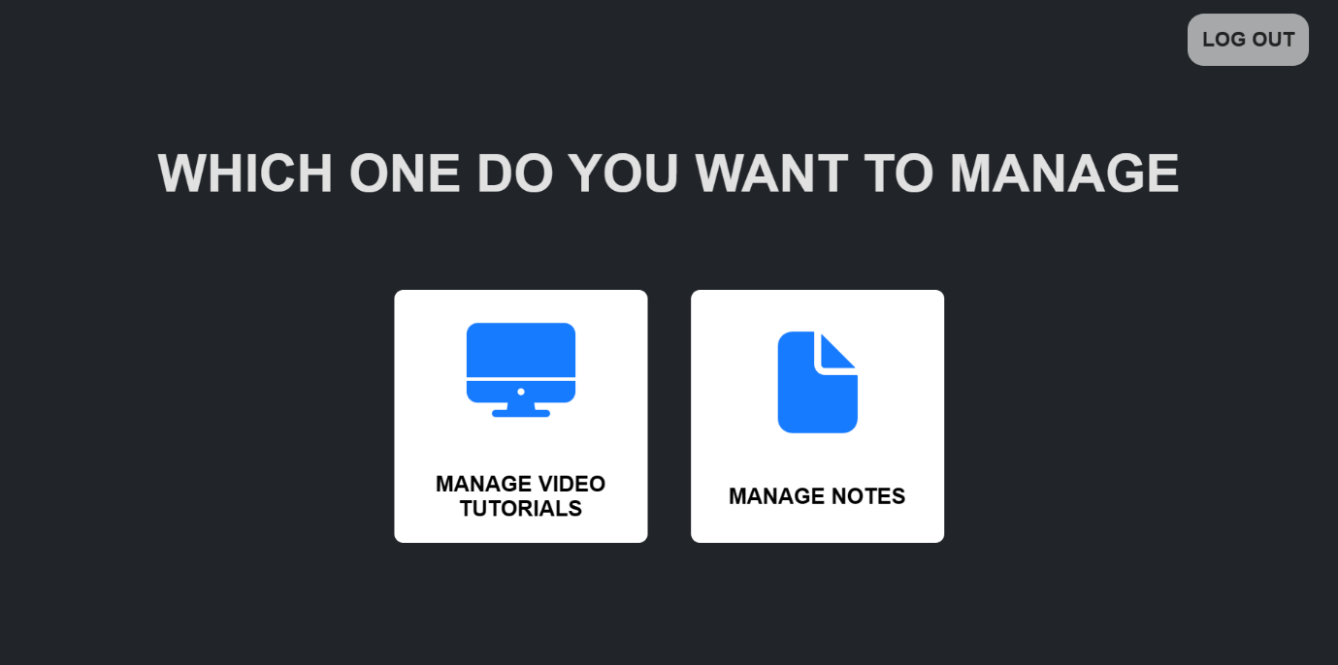

[Manage Page]

**Manage Video Tutorials**

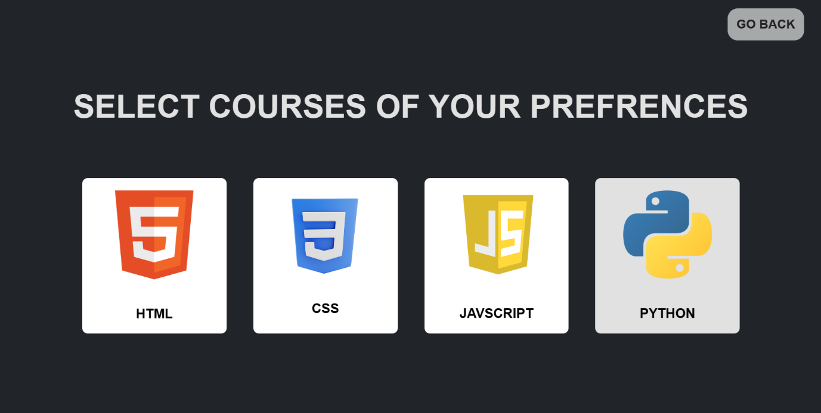

[Manage Video Tutorial Page]

**Html Video Tutorials Upload**

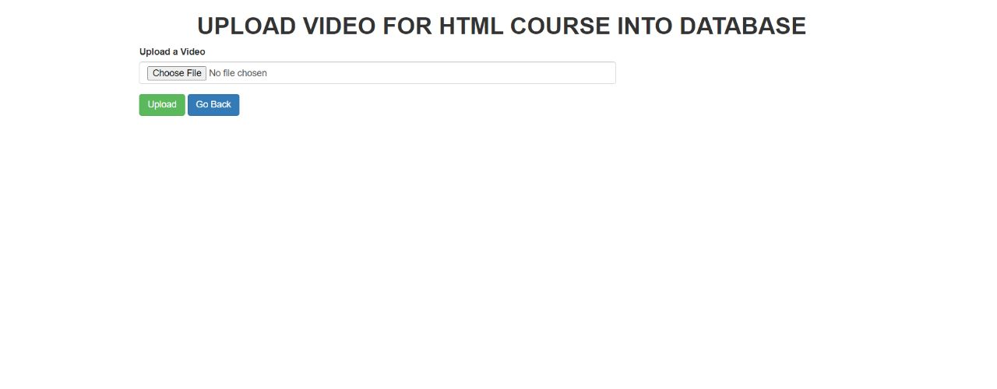

[Html Video Upload Page]

**Html Video Tutorials Manage**

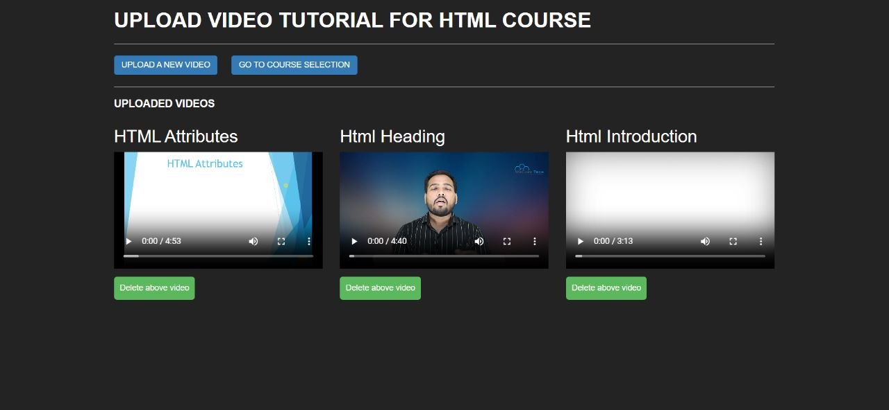

[Html Videos Manage Page]

**CSS Video Tutorials Upload**

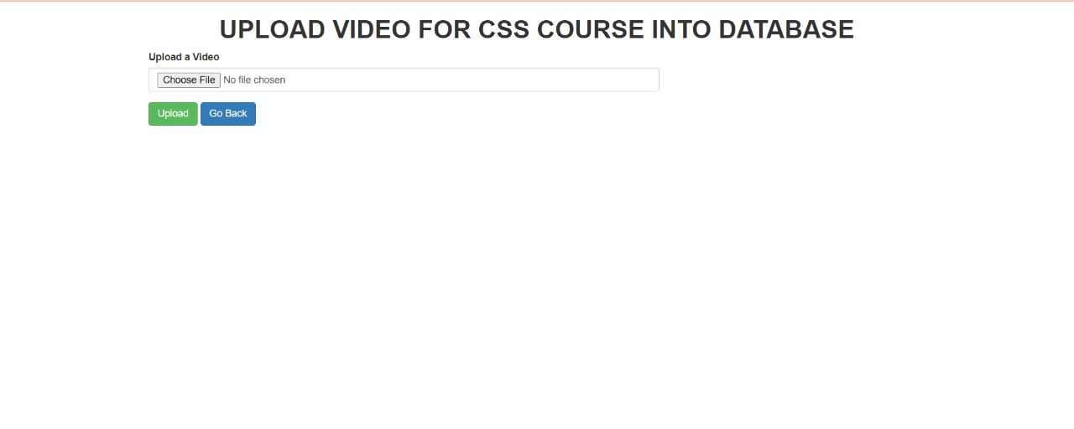

[CSS Video Upload Page]

**CSS Video Tutorials Manage**

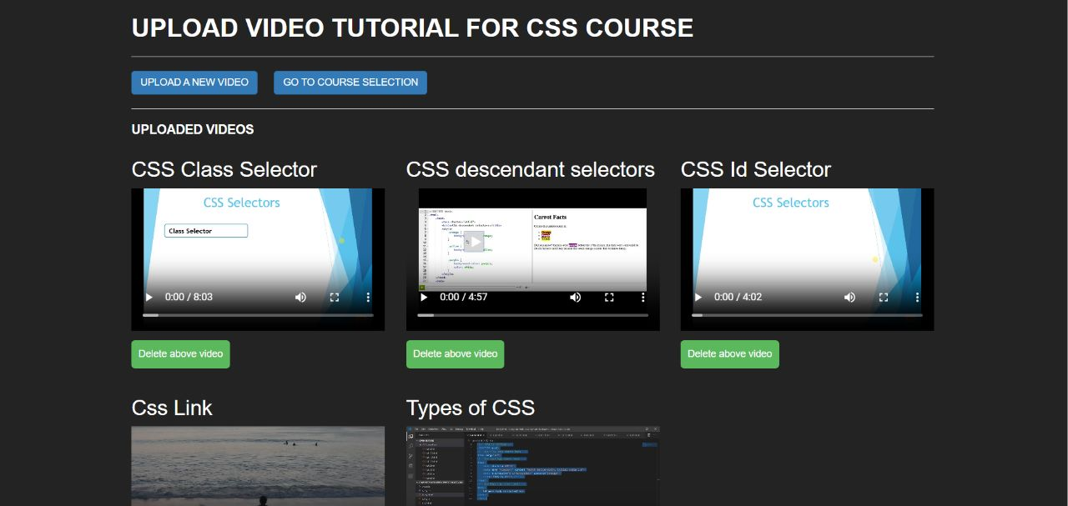

[CSS Videos Manage Page]

**Python Video Tutorials Upload**

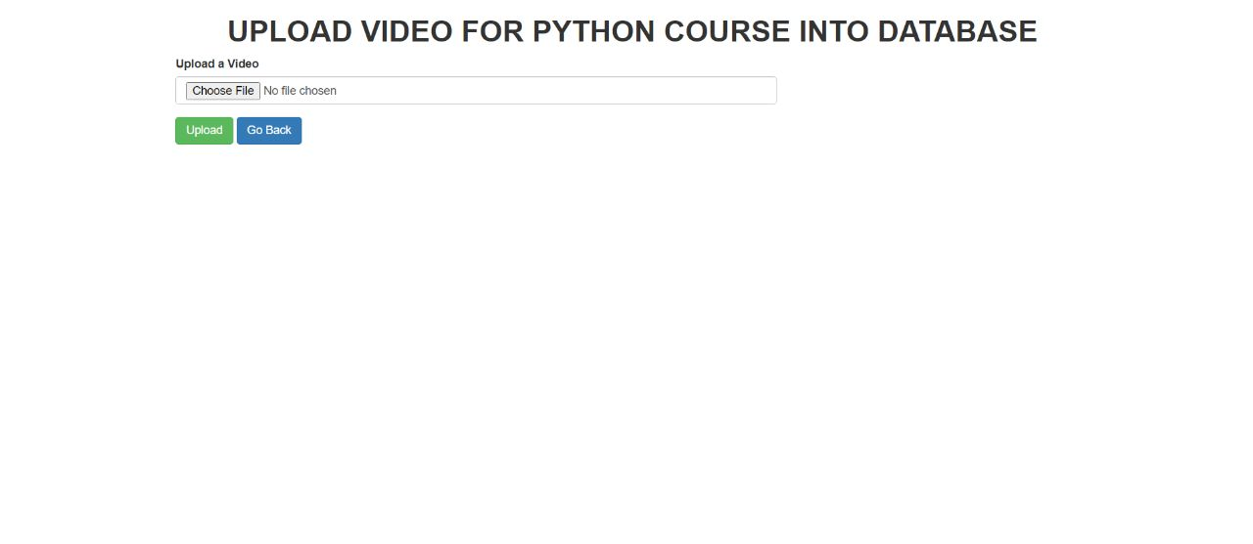

[Python Video Upload Page]

**Python Video Tutorials Manage**

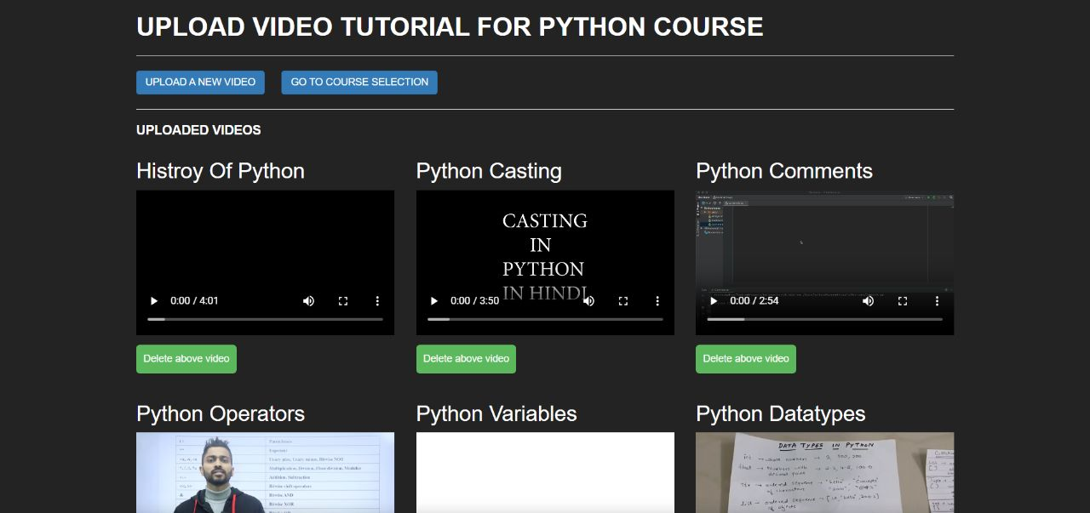

[Python Videos Manage Page]

**JavaScript Video Tutorials Upload**

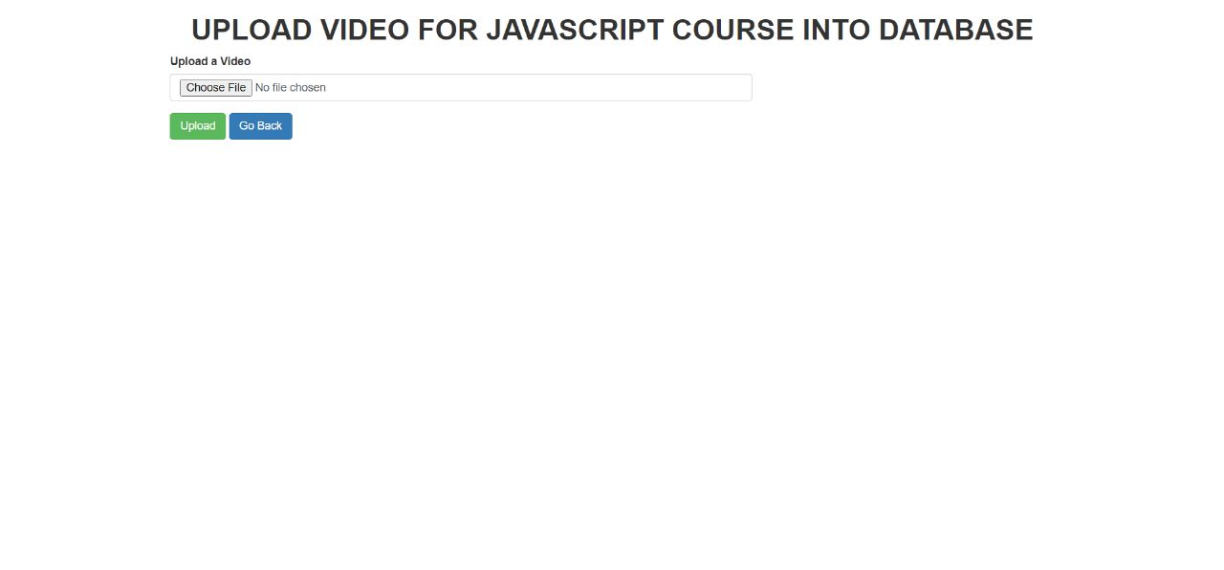

[JavaScript Video Upload Page]

**JavaScript Video Tutorials Manage**

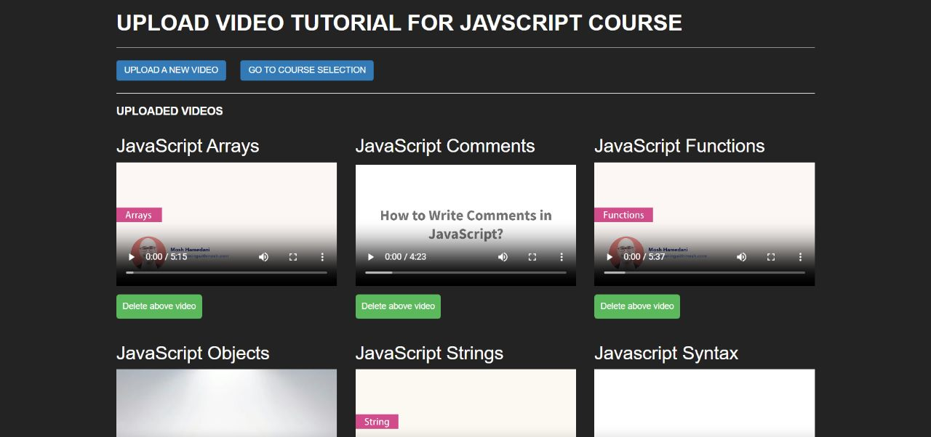

[JavaScript Videos Manage Page]

**Upload Notes**

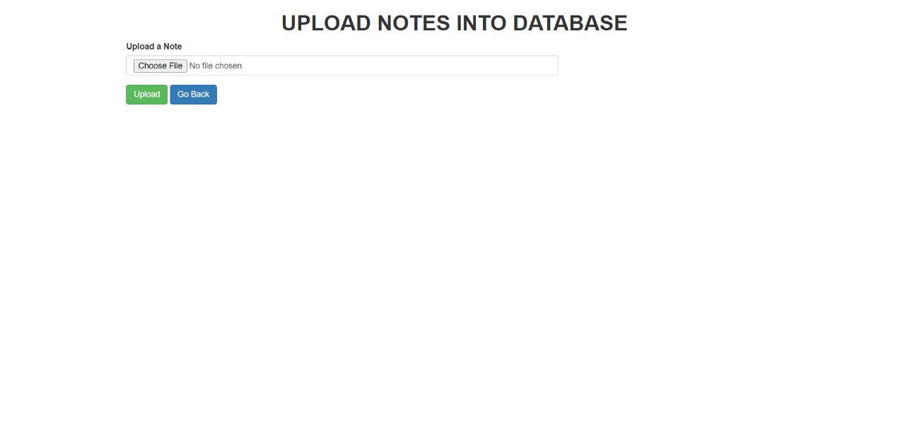

[Upload Notes Page]

**Manage Note**

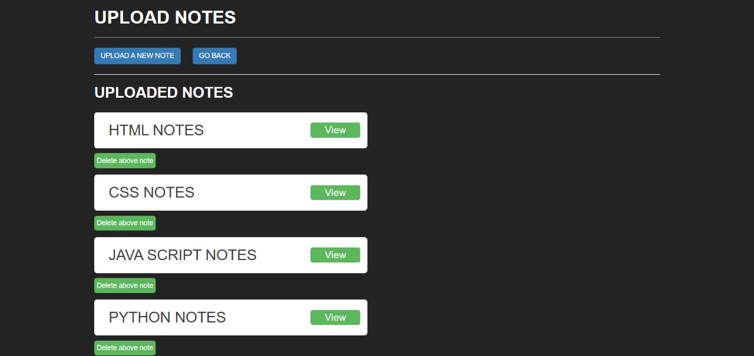

[Note Upload Page]

**User**

**Home**



[Home Page]

**Courses**

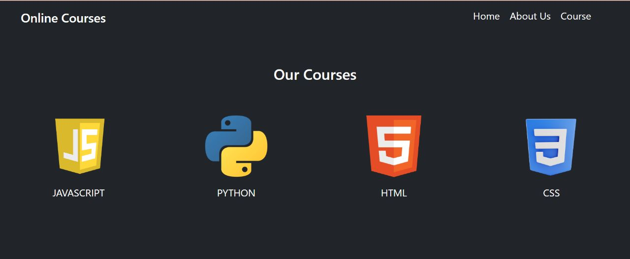

[Courses Page]

**Reviews**

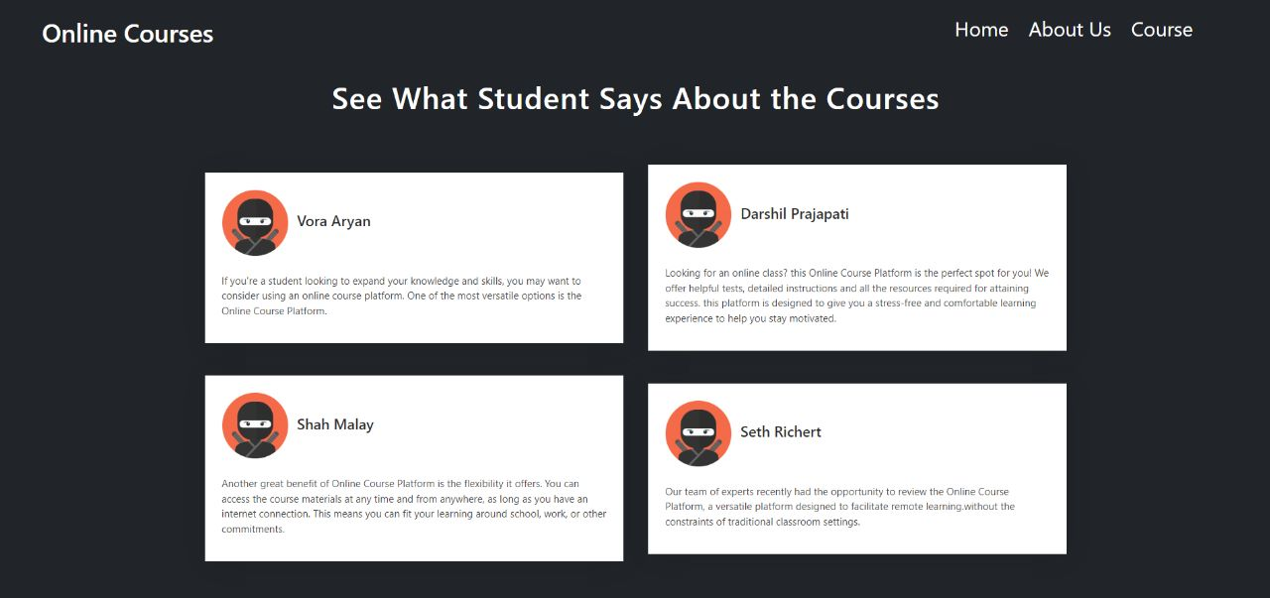

[Reviews Page]

**About Us**

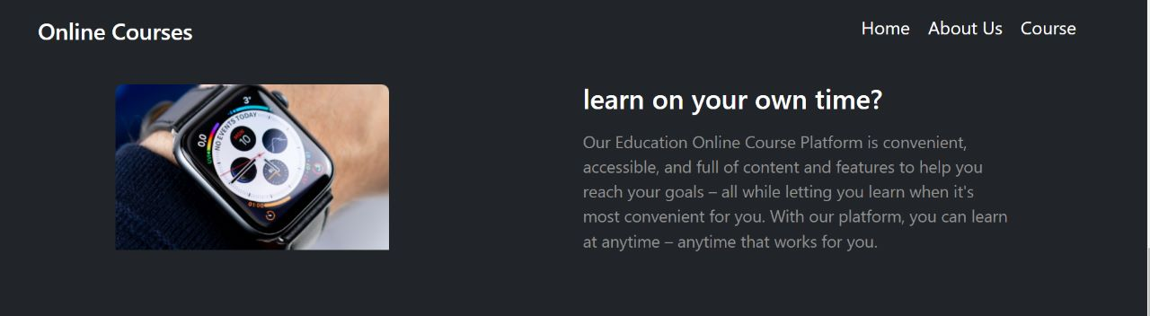

[About Us]

**User Login**

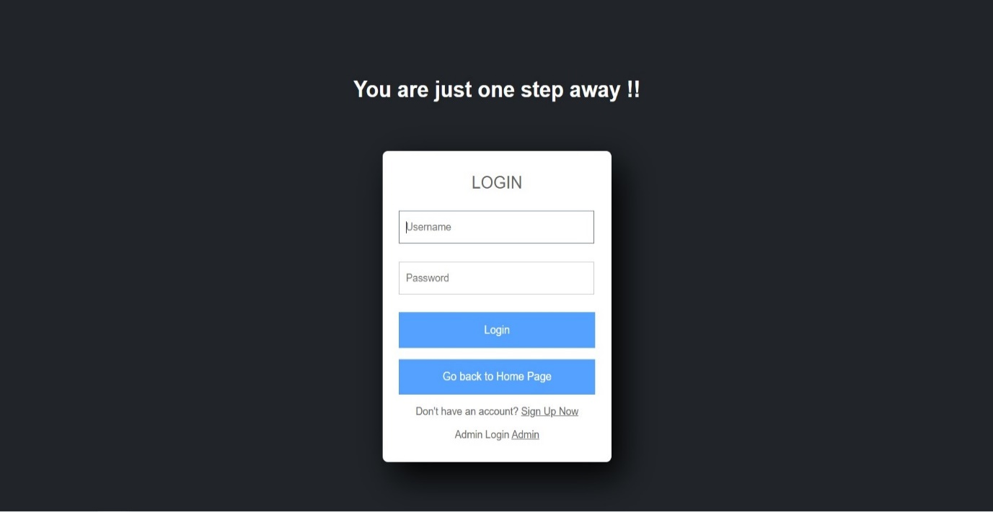

[User Login Page]

**User Registration**

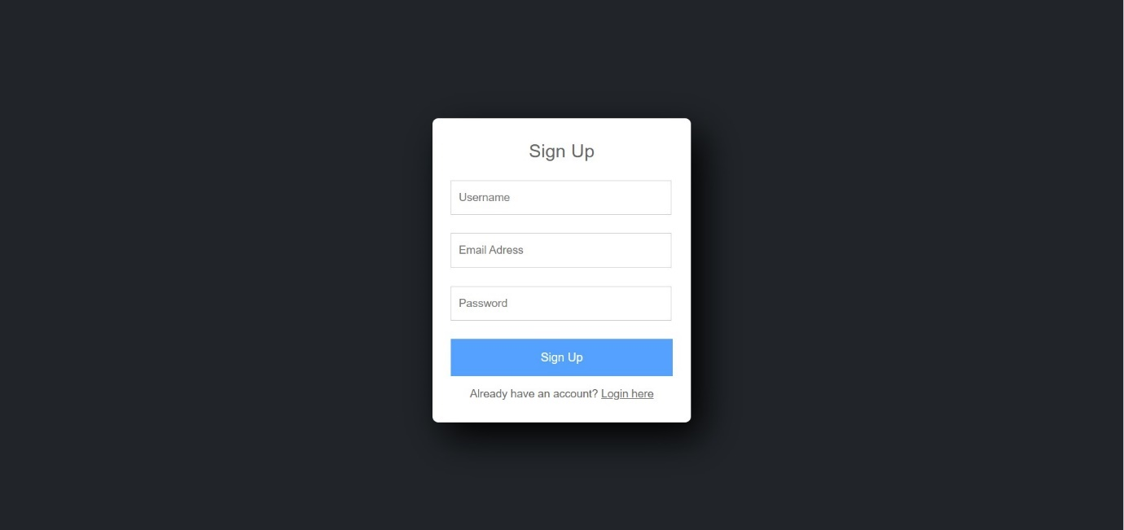

[User Registration Page]

**Change Password**

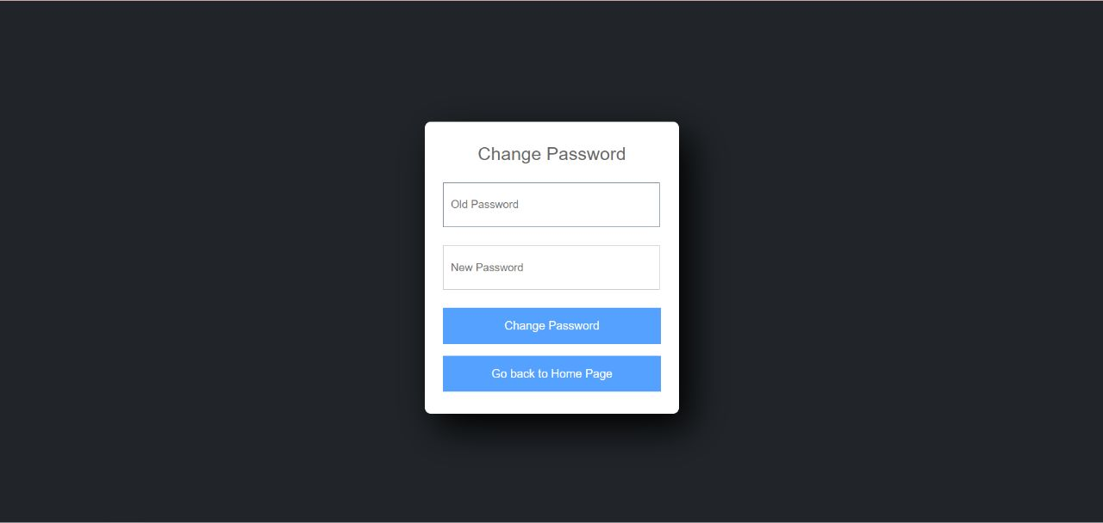

[Change Password Page]

**Dashboard**

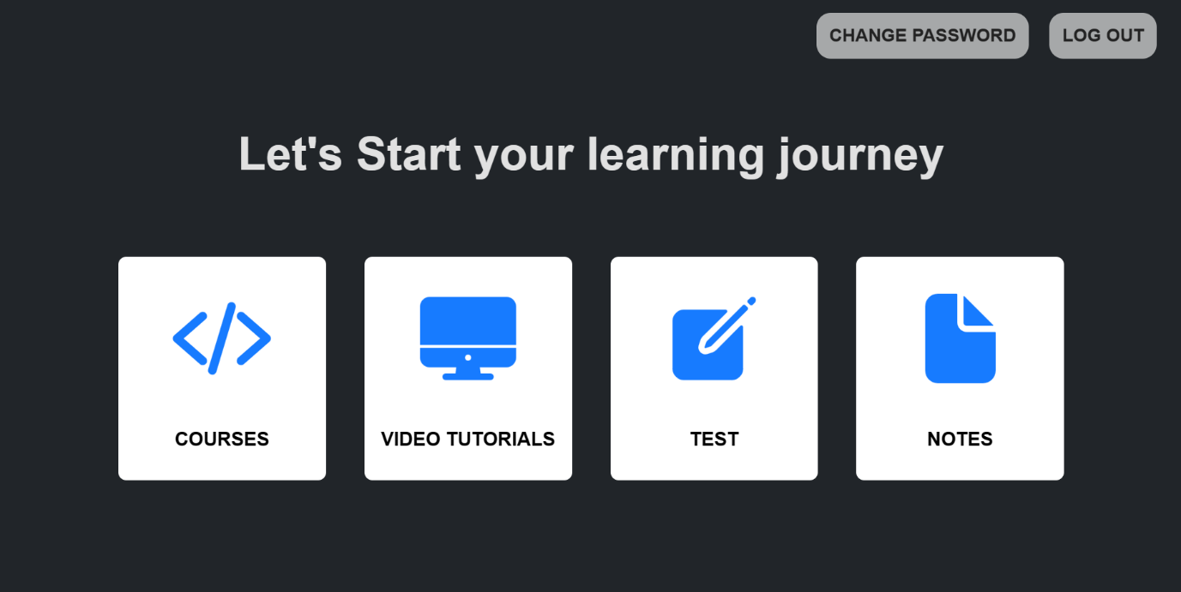

[Dashboard Page]

**Select Course**

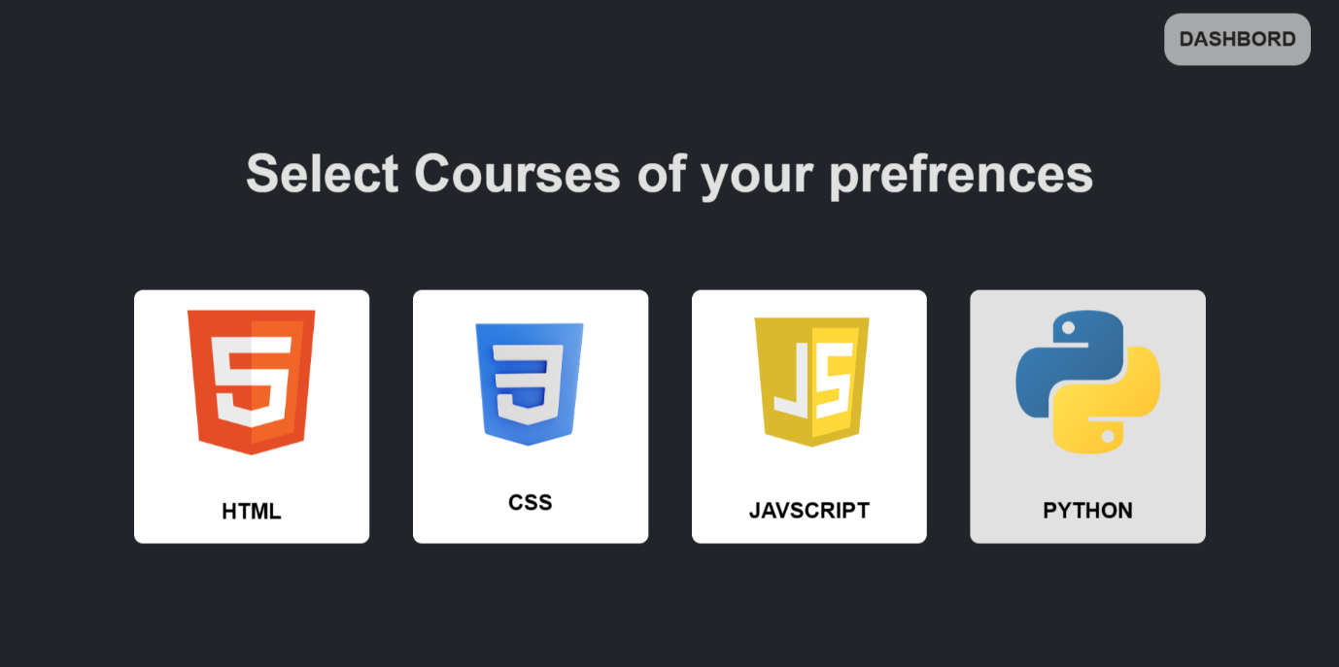

[Select Course Page]

**Html Course**

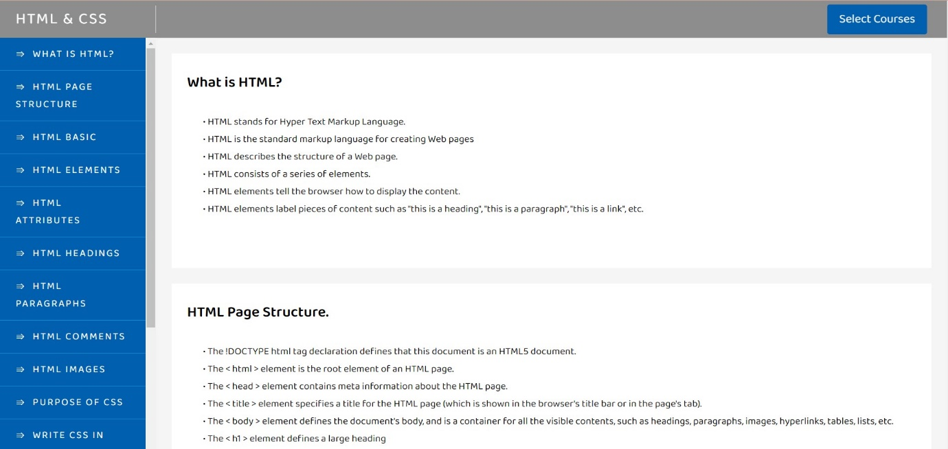

[Html Course Page]

**CSS Course**

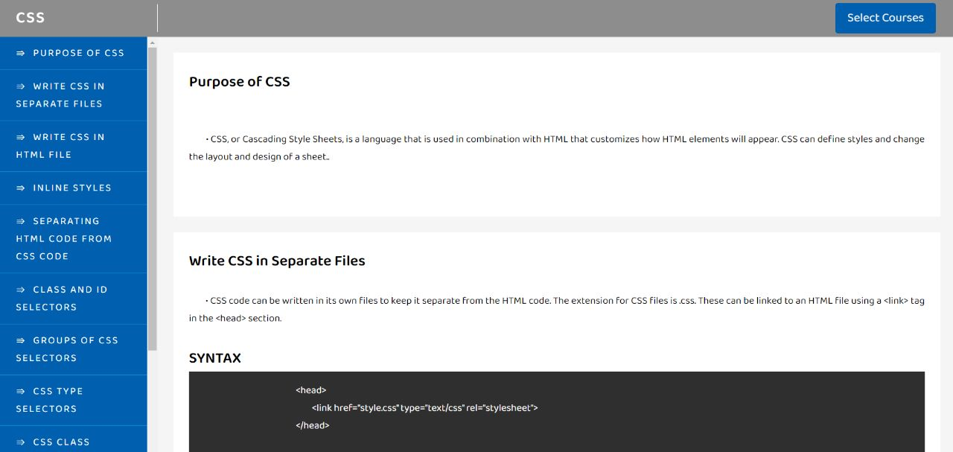

[CSS Course Page]

**JavaScript Course**

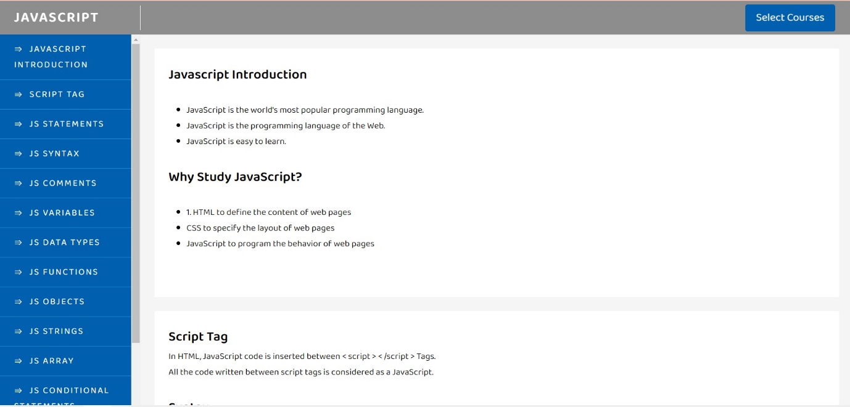

[JavaScript Course Page]

**Python Course**

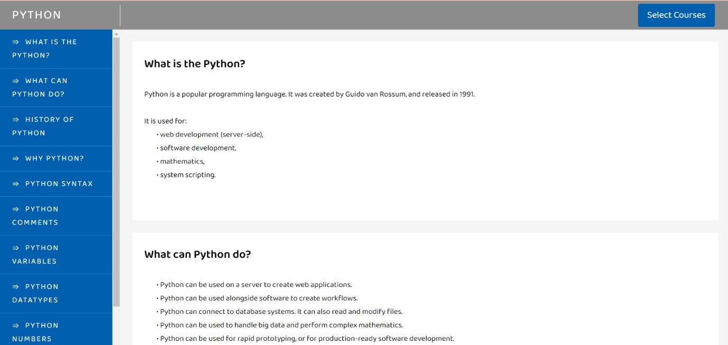

[Python Course Page]

**Html Video Tutorial**

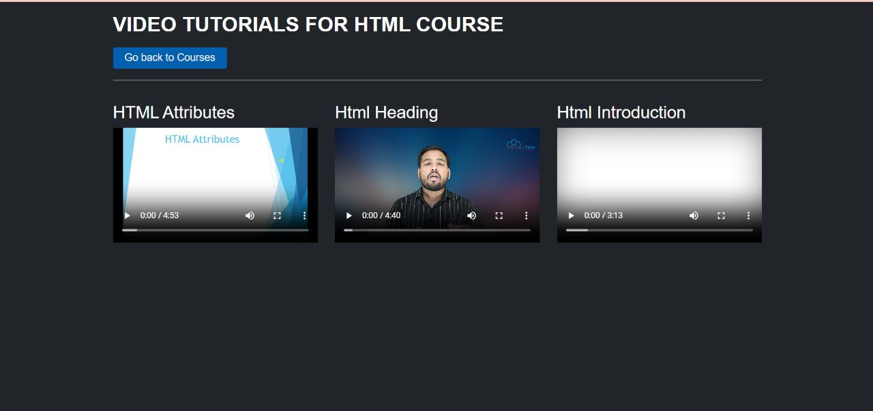

[Html Video Tutorial Page]

**JavaScript Video Tutorial**

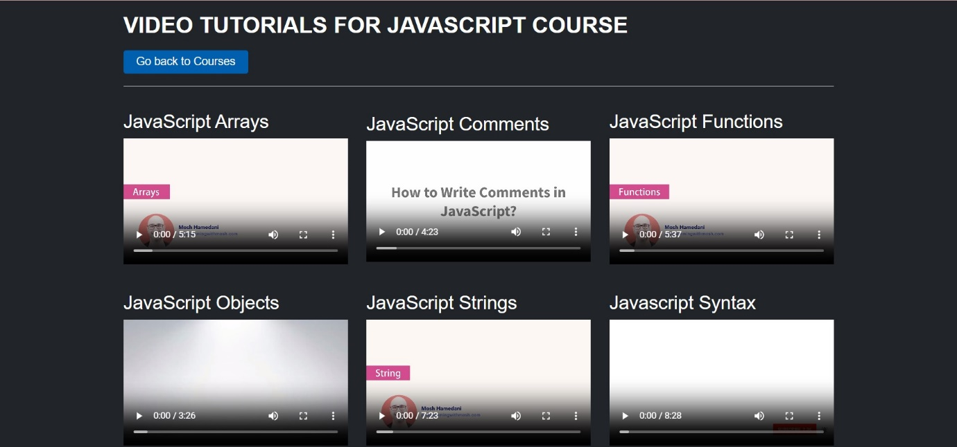

[JavaScript Video Tutorial Page]

**Python Video Tutorial**

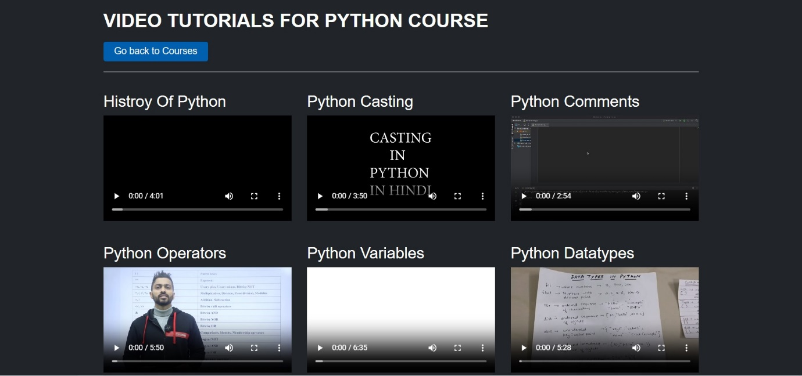

[Python Video Tutorial Page]

**CSS Video Tutorial**

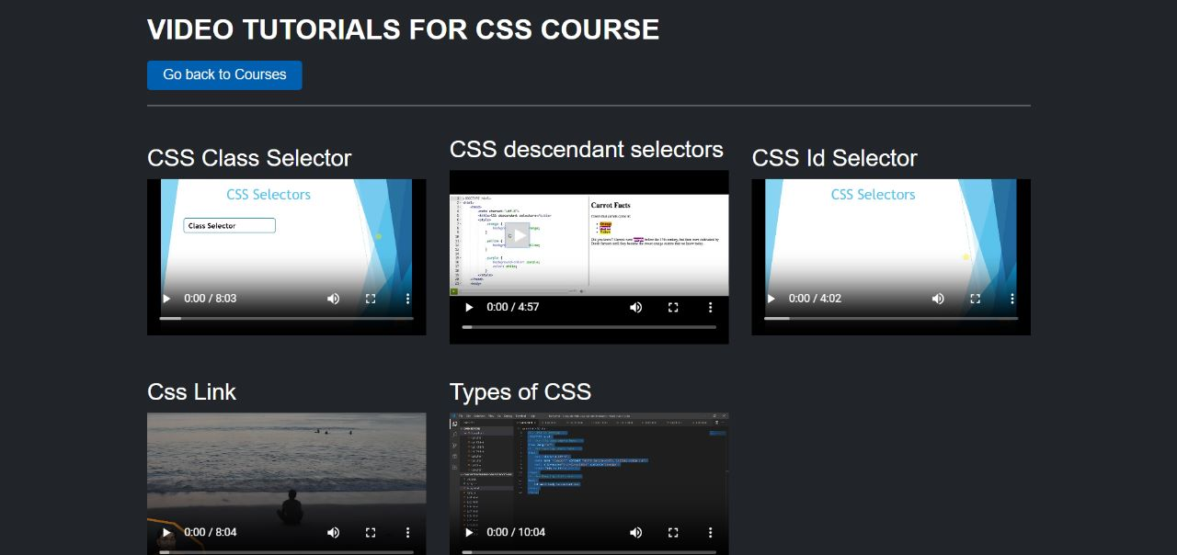

[CSS Video Tutorial Page]

**Quiz Selection**

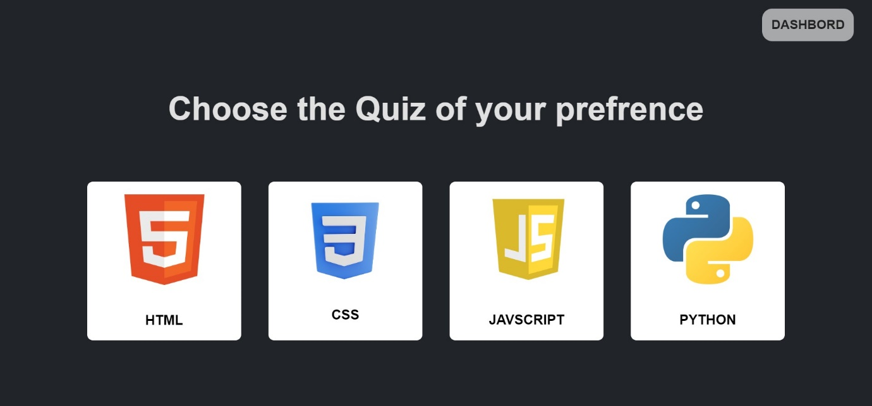

[Quiz Selection Page]

**Html Quiz**

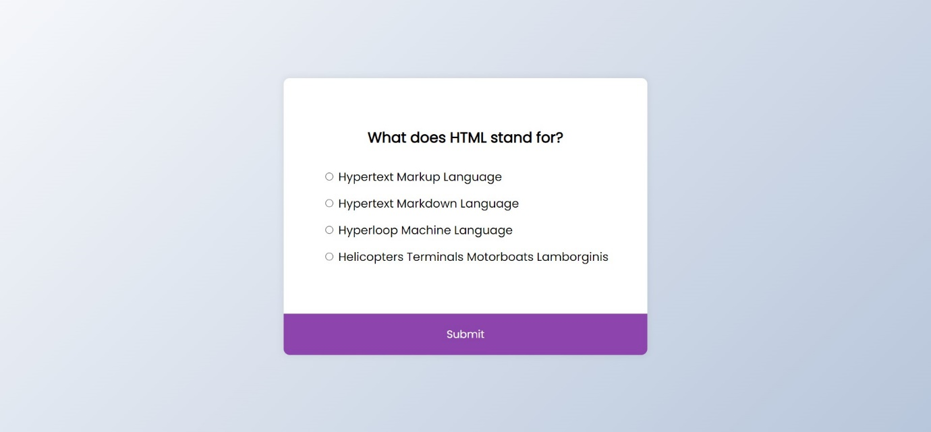

[Html Quiz Page]

**CSS Quiz**

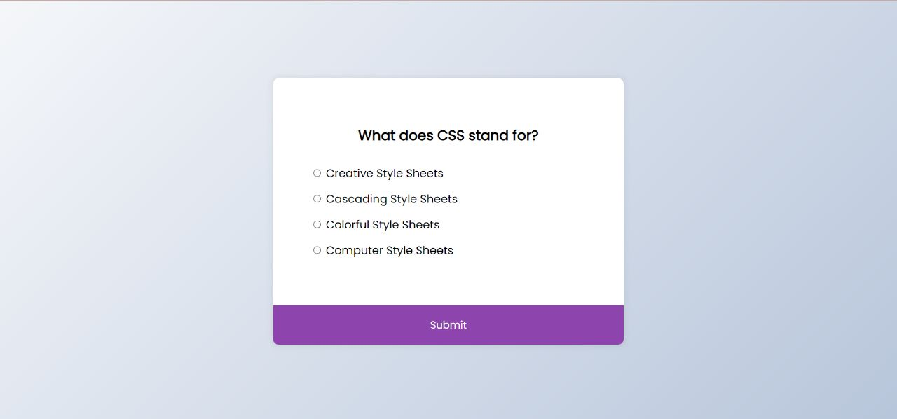

[CSS Quiz Page]

**JavaScript Quiz**

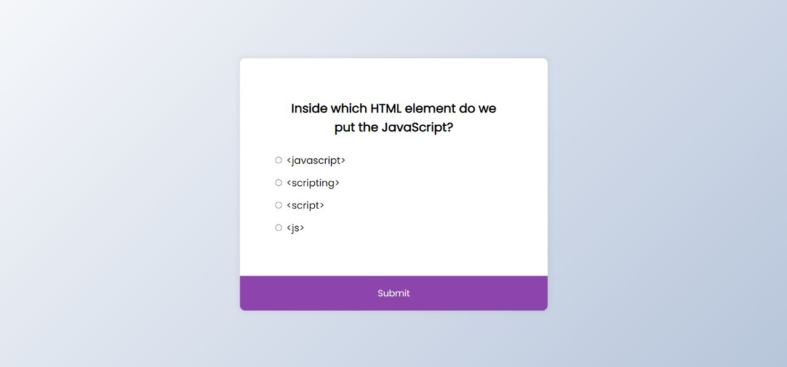

[JavaScript Quiz Page]

**Python Quiz**

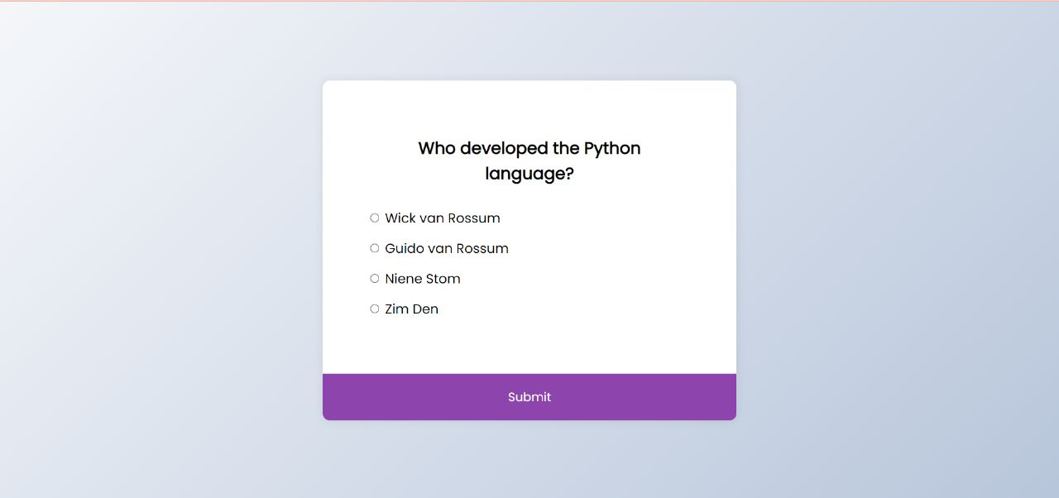

[Python Quiz Page]

**Quiz Result Page**

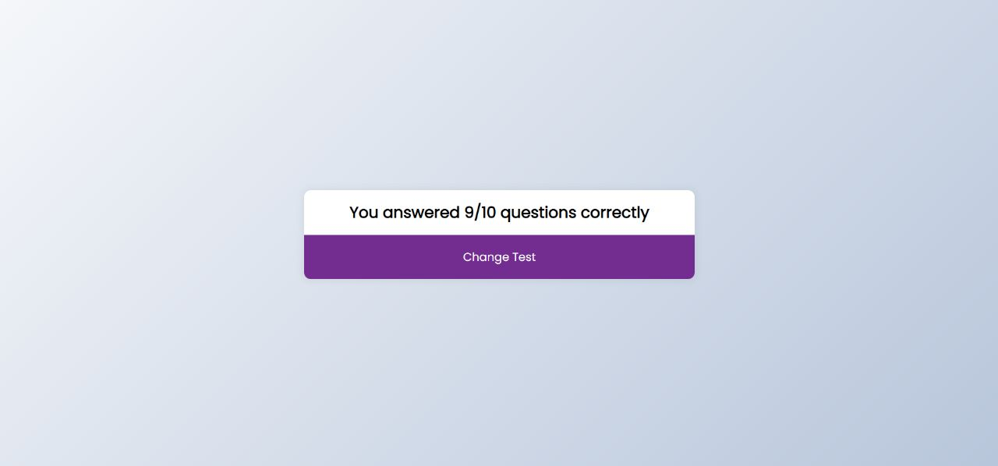

[Quiz Result Page]

**Last Minute Notes**

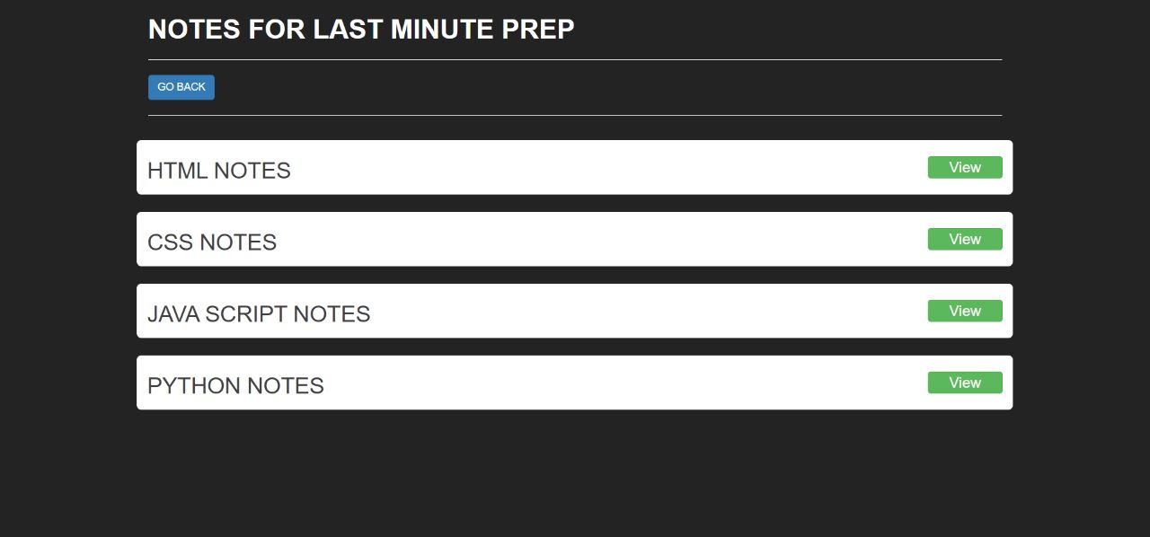

[Last Minute Note Page]

**Notes View**



[Notes View]

**4. Testing**

**4.1 Unit testing**

**Admin testing**

**Test Case for Admin – Login**

|  |  |  |  |  |
| --- | --- | --- | --- | --- |
| Id | Test field | Step Execute | Executed Result | Actual Result |
| 1 | Username | Empty Or Wrong | Msg. ‘please correct or require your  Username | As Expected |
| 2 | Password | Empty and length>=6 characters | Msg. ‘please correct or require your  password | As Expected |

**User Testing**

**Test Case for User – Registration**

|  |  |  |  |  |
| --- | --- | --- | --- | --- |
| Id | Test field | Step Execute | Executed Result | Actual Result |
| 1 | Username | Empty Or Wrong | Msg. ‘please require your  Username | As Expected |
| 2 | Email | Empty | Msg ‘please required your email ’ | As Expected |
| 3 | Password | Empty | Msg. ‘please require your  password | As Expected |

**Test Case for User – Login**

|  |  |  |  |  |
| --- | --- | --- | --- | --- |
| Id | Test field | Step Execute | Executed Result | Actual Result |
| 1 | Username | Empty Or Wrong | Msg. ‘please require or correct your  Username | As Expected |
| 2 | Password | Empty | Msg. ‘please require or correct your  password | As Expected |

**Test Case for User – Change Password**

|  |  |  |  |  |
| --- | --- | --- | --- | --- |
| Id | Test field | Step Execute | Executed Result | Actual Result |
| 1 | Old Password | Empty Or Wrong | Msg. ‘please require or correct your  Username | As Expected |
| 2 | New  Password | Empty | Msg. ‘please require or correct your  password | As Expected |

**4.2 Navigation Testing**

**Admin**

|  |  |  |
| --- | --- | --- |
| **Link** | Expected Page | Result Of Page |
| **Admin Login** | Admin Login page | Admin Login Page |
| **Manages** | Manage Page | Manage Page |
| **Select Course** | Select Course Page | Select Course Page |
| **Html** | Html Video Page | Html Video Page |
| **CSS** | CSS Video Page | CSS Video Page |
| **JavaScript** | JavaScript Video page | JavaScript Video Page |
| **Python** | Python Video Page | Python Video Page |
| **Manage Note** | Manage Note | Manage Note |
| **Notes** | Notes Page | Notes Page |
| **Logout** | Logout | Home Page |

**User**

|  |  |  |
| --- | --- | --- |
| **Link** | Expected Page | Result Of Page |
| **Home** | Home Page | Home Page |
| **Login** | Login Page | Login Page |
| **Registration** | Registration Page | Registration Page |
| **Change Password** | Change Password Page | Change Password Page |
| **Dashboard** | Dashboard Page | Dashboard Page |
| **Course** | Course Page | Course |
| **Html Course** | Html Course Page | Html Course Page |
| **CSS Course** | CSS Course Page | CSS Course Page |
| **JavaScript Course** | JavaScript Course Page | JavaScript Course Page |
| **Python Course** | Python Course Page | Python Video Page |
| **Video Tutorials** | Video Tutorials Page | Video Tutorials Page |
| **Html Video Tutorials** | Html Video Tutorials Page | HTML Video Tutorials Page |
| **CSS Video Tutorials** | CSS Video Tutorials Page | CSS Video Tutorials Page |
| **JavaScript Video Tutorials** | JavaScript Video Tutorials Page | JavaScript Video Tutorials Page |
| **Python Video Tutorials** | Python Video Tutorials Page | Python Video Tutorials Page |
| **Test** | Test Page | Test Page |
| **Html Test** | Html Test Page | Html Test Page |
| **CSS Test** | CSSTest Page | CSS Test Page |
| **JavaScript Test** | JavaScript Test Page | JavaScript Test Page |
| **Python Test** | Python Test Page | Python Test Page |
| **Notes** | Notes page | Notes page |
| **Html Note** | Html Note Page | Html Note Page |
| **CSS Note** | CSS Note Page | CSS Note Page |
| **JavaScript Note** | JavaScript Note Page | JavaScript Note Page |
| **Python Note** | Python Note Page | Python Note Page |
| **Logout** | Logout | Home Page |

**4.3 Functional Testing**

* + - Login and Password process has been co-operated properly.
    - Registration system module has been done properly and accurately.
    - Password updating is working properly.
    - All session working properly.
    - Visibility of Dashboard wise Course are working Properly.
    - User registration is working Properly.
    - Courses manage properly.
    - Video Uploading is working properly.
    - Quiz is working properly.
    - Notes manage properly.
    - Delete Video from Admin Side Working properly.
    - All Pages Design is perfect.

**4.4 Environment Testing**

Firefox browser, Internet explorer and chrome consider testing for environment operability of software.

* + Web server – Apache/xampp
  + Database – MYSQL Server
  + OS – Windows 11
  + Browser – Firefox/Internet Explorer/Chrome

**5. Conclusion**

* Technology has made significant progress over the years to provide users a better learning experience and will continue to do so for years to come. With the rapid growth of technology and innovations, people have speculated that online learning will overtake offline learning.
* However, there are some drawbacks to online courses. One of the major problems is face to face interaction between students and instructor. Furthermore, we have been noticed that most of the students just login into our website but later on they won’t give any interest to it.
* Overviewing both the points there are more advantages which outweigh the disadvantages of online course platform. Because the quality which are given online is far more updated and important comparing to the hardcover course which is been given free of cost.

**6. Bibliography & Reference**

* Website which helps us in our project are given below.

1. [www.google.com](http://www.google.com)
2. [www.w3school.com](http://www.w3school.com)
3. [www.youtube.com](http://www.youtube.com)
4. [www.draw.io.com](http://www.draw.io.com)